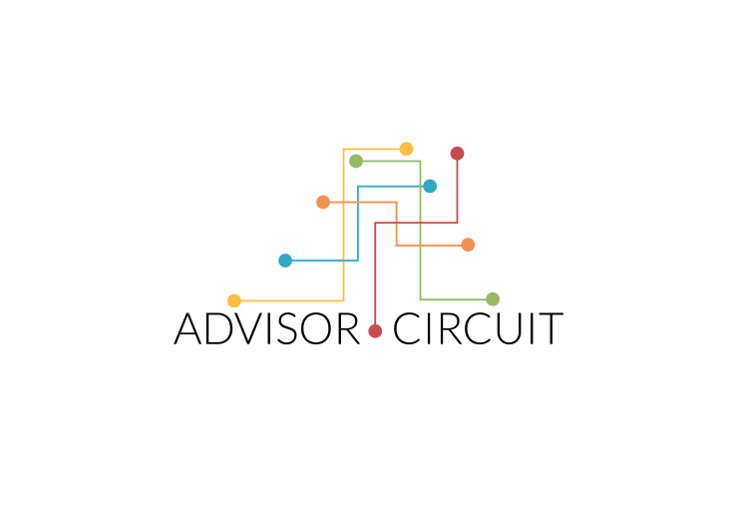

**ADVISOR REGISTRATION FORM**

**This form contains 5 sections, namely:**

1. **General Information**
2. **Educational Qualifications**
3. **Professional Background**
4. **Other Information**
5. **Services**

**All fields given are mandatory to fill, if the field given does not apply to you then please enter “N/A”.**

**If you have any doubts or queries, please feel free to contact us on +91 9971232582, +91 9999828839 or write to us at** [**adityaraina@advisorcircuit.com**](mailto:adityaraina@advisorcircuit.com)**,** [**laviaggarwal@advisorcircuit.com**](mailto:laviaggarwal@advisorcircuit.com)**.**

**I. GENERAL INFORMATION**

[This section covers some basic details about you]

Name: Rohan Chhabra

Gender: Male

Age: 27

Phone Number [Please enter 10 Digit Mobile Number]:

Email Address:

Personal Address:

City:

State:

Nationality: Indian

PAN Number [For payment purposes]:

Industry [Please enter your work industry] [Example: Advertising]: Fashion Designing

Current Occupation:

Name of Organization [Name of your current workplace]:

Job Title:

Experience in Relevant Industry [Enter number of years you've worked in the above mentioned industry]:

**II. EDUCATIONAL QUALIFICATIONS:**

[This Section covers details regarding your education]

Under-Graduation [Please enter Institute, course and year of under-graduation]:

BA Fashion Design, Pearl Academy of Fashion, Delhi [2004-2008]

Post-Graduation [Please enter Institute, course and year of post-graduation]:

MA Industrial Design, Central Saint Martins College of Art and Design, University of Arts, London[ 2008 – 2010]

**III. PROFESSIONAL BACKGROUND:**

[This section covers your work experience through the years. Please mention all the organizations you have worked with, the duration and a brief description about your work there]

Work Experience 1:

Company [Name of Organization] [Example: JWT - Delhi]: Studiotoogood

Designation [Job Title] [Example: Vice-President]:Freelance Product Designer

Duration [Mention Approximate duration in Years & Months] [Example: 2009- Current]: [aug – sept 2010]

Description [A brief description of your role in the above mentioned organization]:

[Example: 1. Manage and develop newspaper, magazine and internet advertising for existing and new accounts while building and cultivating client relations by continually updating my knowledge of the ever-changing media and market.

2. Assist with the clients advertising strategy, ad message and creative development.

3. Consistently grew business and established strong relationships with clients.]

Work Experience 2:

Company [Name of Organization]: NIKE

Designation [Job Title]: Product Designer

Duration [Mention Approximate duration in Years & Months]: Jan 2011- Nov 2012

Description [A brief description of your role in the above mentioned organization]:

Work Experience 3:

Company [Name of Organization]:Embodying ethics: Endangered

Designation [Job Title]:

Duration [Mention Approximate duration in Years & Months]: Current

Description [A brief description of your role in the above mentioned organization]:

* Aims to inform the issue of extinction of critical endangered species
* The project was exhibited at the 2013 London Design Festival

**IV. OTHER INFORMATION:**

[This section covers some additional information like your key skills which will help the user in understanding you better and how you can help them]

Awards & Achievements [Any awards and recognitions you have received over the course of your career]:

[Example: 1. Award for excellent salesmanship in 2010

2. Part of teams which got nominated and won several prestigious awards in advertising]

* Won Livingetc New Designer Awards in collaboration with Royal Society for the Arts. Innovator of new Material Award (CSM 2010)
* Finalist in the PELLE+ Leather Design Competition judged by Oiliviero Toscani (CSM 2010)
* Best Design Project in UK, 2010 by Blueprint Magazine of Design and Architecture. Published in BLUEPRINT.(September 2010 issue)
* Best Design project in UK 2010 by Craft Magazine, published in CRAFT. (September/October 2010 issue)
* Best Design Project featured in Vogue Italy. (January 2011)
* Won Cigarette Lighter Competition in collaboration with BAIDE Lighter, China. (CSM 2009)
* Won full tuition Scholarship sponsored by Royal Society of Arts and University of Arts to pursue MA Industrial
* Design at the prestigious Central Saint Martins College of Art and Design, London. (CSM 2008)
* Won the Avant Garde Collection Award at the Graduation show for the Collection 'The Mavericks'. ( Pearl Academy 2008)
* Finalist in the GAP (RED) competition. (Ravensbourne College of Design and Communication 2007)

Key Skills [Describe areas of proficiency in which you can guide customers for career growth]

[Example: 1. Specialize in market research and understanding consumer behavior,

2. Extensive knowledge about the field of advertising,

3. How to prepare for a career in digital marketing,

4. How to work with multi-cultural teams]

Hobbies & Interests:

A fun fact about yourself [Please mention something interesting about yourself or what you like to do]:

[Example: I love animals. I have had various pets since I was a child ranging from a dog, a cat, a hamster, a parrot and a squirrel!]

**V. SERVICES:**

[This section covers details of the services you want to offer. Please mention ‘Yes’ for the service you want to offer and enter your decided price per hour per session for a particular mode of communication.]

[The price for phone and web-chat for any service will be the same]

**[Certain services have limited number of modes of communication. Please refer to the Services document provided to you in the folder for any doubts or explanation of the services.]**

**CAREER TALK:**

Yes/No [Whether you want to offer this service]:

Description [Please explain why you are choosing to offer this service]:

[Example: My 10 years spent in the advertising industry has given me extensive knowledge to answer and clear any doubts regarding the profession and also help someone grow in this field]

Mode of Communication [Which modes of communication would you be available for]:

Phone:

Yes/No:

Price: (Rs.)

Web-chat:

Yes/No:

Price: (Rs.)

Email:

Yes/No:

Price: (Rs.)

**MOCK INTERVIEW:**

Yes/No [Whether you want to offer this service]:

Description [Please explain why you are choosing to offer this service]:

[Example: I have conducted interviews and recruited over 50 individuals for various positions and feel confident that I can give you a close to reality interview experience]

Mode of Communication [Which modes of communication would you be available for]:

Phone:

Yes/No:

Price: (Rs.)

Web-chat:

Yes/No:

Price: (Rs.)

**CV CRITIQUE:**

Yes/No [Whether you want to offer this service]:

Description [Please explain why you are choosing to offer this service]:

[Example: I have scanned and shortlisted various resumes over the span of my career and know what recruiters look for in potential candidates]

Mode of Communication [Which modes of communication would you be available for]:

Phone:

Yes/No:

Price: (Rs.)

Web-chat:

Yes/No:

Price: (Rs.)

**PERSONAL WORKSHOPS:**

Yes/No [Whether you want to offer this service]:

Price: (Rs.)

Description [Please explain why you are choosing to offer this service]:

[Example: I've learnt certain niche skills on the job and I believe that I can help anyone interested to get a better understanding of the same]